## Setting up the Eclipse for Java

Download JDK

<https://www.oracle.com/java/technologies/javase-downloads.html>

Download Eclipse for Java

<https://www.eclipse.org/downloads/>

Video Guide to Setup Eclipse for Java with JDK

<https://www.youtube.com/watch?v=qyZnzCcE3-o>

## Getting Started with Eclipse

1. Locate and run Eclipse by clicking on the icon on your desktop or select Eclipse from the Start menu (if multiple versions are installed make sure you select Eclipse for Java Developers). This is the development environment that we will be using for this unit. You can also download Eclipse to use at home. Watch the video on moodle week 2 tutorial section to download eclipse at home.



1. The first time that Eclipse runs you will be asked to setup a workspace – this is an area that is used to store your programs.

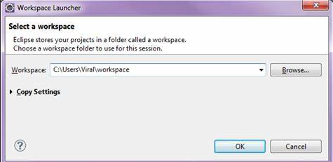

1. Chose a folder on your j: or USB drive so that you do not lose the work that you do in the labs. **Do not use the C: drive for this, or you may lose this work when you log out of this PC**. Click on OK.
2. The following window (or similar depending on your version of Eclipse) will be displayed:

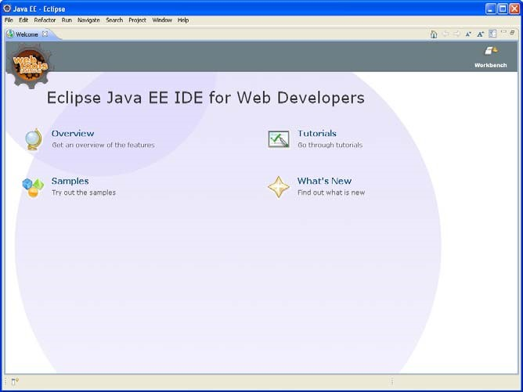

1. Eclipse provides a number of resources, such as the Tutorials, that are worthwhile completing. Spend time now or at home working through these resources.
2. Click on the Workbench button (top right of the window) and the workbench will now be displayed.

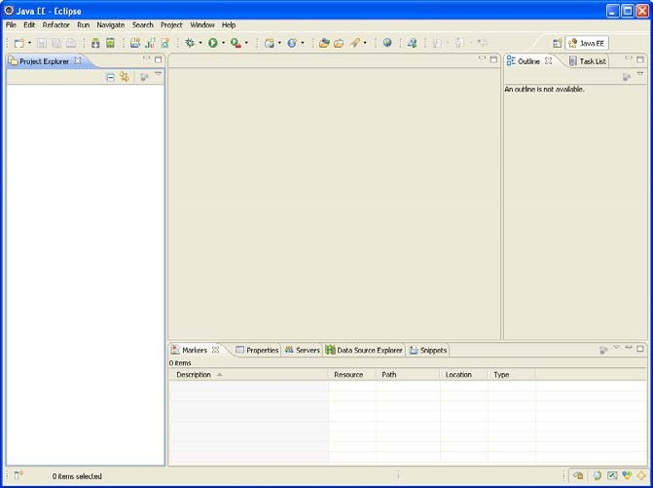

1. For Java applications (programs) are developed and stored in **Projects**. To create a new project go to the menu File’ and select ‘New’ and then choose ‘Project . . .’
2. A dialog box (called a ‘wizard’) will now appear to help you through the rest of the project creation: a. Select ‘Java Project’ – click Next

b. In Project Name: type ‘labs’ (without the quotes). – click finish

You might be asked if you want to use the Java Perspective. A perspective refers to the way the various frames are organised on the workbench. Select ‘Yes’.

The new project will now appear in the Package Explorer in the left panel of the screen. Spend some time exploring the files and directories associated with the new project (click the + button to open up hierarchies).

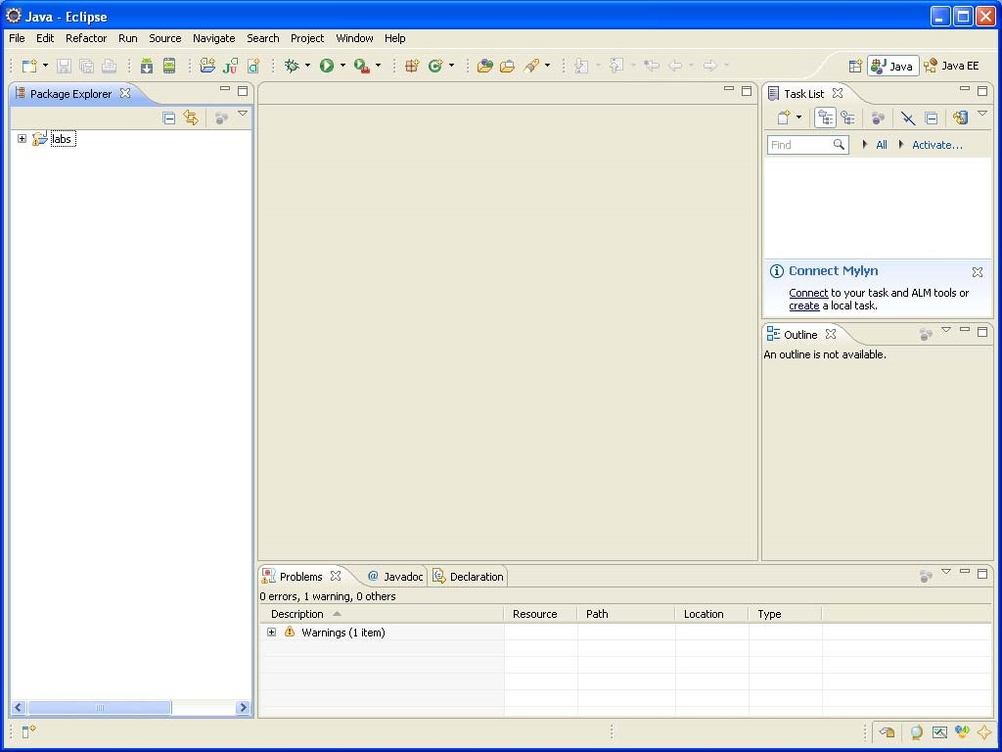

1. The code for Java projects is contained in **classes**. Related classes are placed in packages. We will now create a package for the lab 1 classes. Note in Eclipse there are often many ways to do the same thing – there are at least 3 ways to create a new package. Once you get used to Eclipse you’ll find the ways that suit you best.
   1. Right-click on ‘labs’ in the Package Explorer.
   2. Select new from the menu that appears.
   3. Select package
2. In the dialog that appears type ‘week 2’ (without the quotes) in the Name: textfield. Don’t leave out the zero – it helps keep them in order. Without the 0, lab11 is listed between lab1 and lab2 alphabetically. The package appears under ‘src’ in the hierarchy in the Package Explorer.

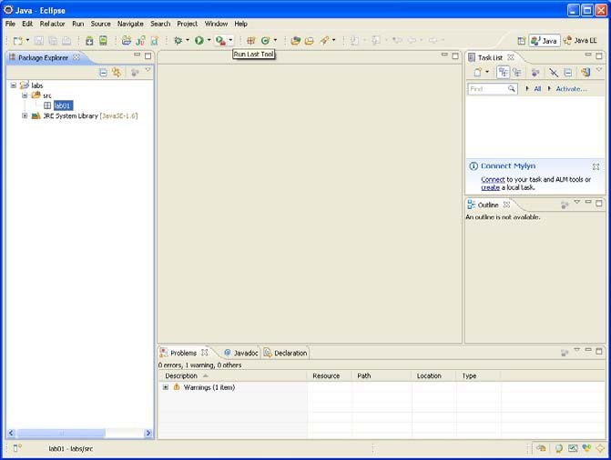

1. Create a new class by clicking on ‘File’ , ‘New’ and then ‘Class’. A new window will be opened.

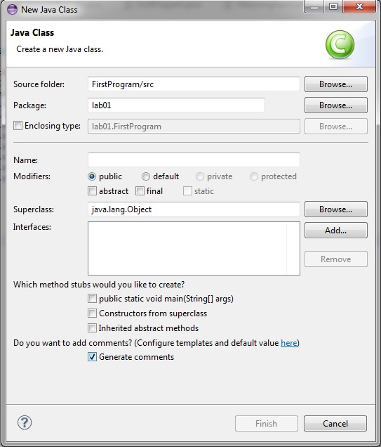

1. Enter FirstProgam into the Name field. Also tick the box to create the ‘public static void main’. Then click on Finish.
2. Copy and paste the code contained in FirstProgram.java provided on Moodle into the main window replacing everything that is currently there and then click on Save (or CTRL- S).
3. You can now run the program by clicking the green circle with the white arrow in the tool bar (again there are several ways to run the program – this is probably the easiest).